Insight Summary

Advanced Python Analysis AAPL Historical Stock Data

Prepared by Amarachi Okoli

Week 6 Batch B

1. Dataset Overview
This analysis uses daily historical stock data for Apple Inc. (AAPL) covering a 5-year period from July 7, 2021 to July 6, 2026 (1,254 trading days). Data was retrieved programmatically using the yfinance Python library, which pulls the same underlying data published by Yahoo Finance, since Yahoo's website has gated direct CSV downloads for this ticker behind sign-in/subscription. The dataset includes seven fields: Date, Open, High, Low, Close, Adjusted Close, and Volume. Upon inspection, the dataset was found to be fully clean, zero missing values and zero duplicate rows across all 1,254 records.

2. Data Transformation Techniques Applied
- Data cleaning: datetime conversion, chronological sorting, duplicate removal, missing value handling via forward/backward fill
- Filtering: isolated trading days with closing price above $200 (494 of 1,254 days, ~39%)
- Sorting: ranked trading days by volume to identify peak trading activity
- Grouping and aggregation: monthly resampling (average, max, min close; total volume) via pandas
- Calculated columns: Daily Range (High/Low) and Typical Price ((High+Low+Close)/3)
- Formatting and restructuring: currency/volume string formatting for readability, and a Year × Month pivot table of average closing price

3. Time-Series Analysis Performed
- Date component extraction (Year, Month, Day of Week) for time based grouping
- Daily percentage change in closing price
- 7 day and 30 day rolling (moving) averages
- Monthly returns via month end resampling
- Day of week performance comparison

4. Features Engineered
- Daily Price Change (absolute $ move) and Daily % Change
- 7 day and 30 day Moving Averages
- 30 day rolling volatility, annualized (× √252 trading days)
- Cumulative return since the start of the dataset
- Trend flag: price position relative to its own 30 day moving average

5. Trends Identified & Key Insights
Overall trend: AAPL's closing price rose from $144.57 (Jul 7, 2021) to $312.66 (Jul 6, 2026) a total return of +116.3% over 5 years. The 5 year low was $125.02 (Jan 5, 2023); the high was $315.20 (Jun 2, 2026).
Moving averages: Price traded above its 30 day MA 55% of the time, with ~97 MA crossover events across the period, signals occur roughly every 3 weeks on average.
Volatility: Annualized 30 day volatility averaged ~26%, spiking to ~70% around April/May 2025, the same window containing the two most extreme single day moves in the dataset (+15.3% on Apr 9, 2025 and -9.25% on Apr 3, 2025), consistent with a broad market shock rather than an AAPL specific event.
Monthly returns: 34 of 60 months (57%) were positive. Best month: July 2022 (+18.9%). Worst month: December 2022 (-12.2%), consistent with the broader 2022 tech sector drawdown.
Day of week effect: Average daily % change is small across all weekdays (range: -0.09% to +0.15%) no reliable, tradeable weekday pattern found.
Trading volume: Average daily volume was ~65.3 million shares, with a peak of ~318.7 million shares on Sept 20, 2024, consistent with an index-rebalancing / options expiration event.

6. Recommendations
- Risk management (position sizing, stop-losses) should flex dynamically around known high volatility windows rather than assume constant risk exposure.
- The 7 day/30 day MA crossover is a simple, interpretable trend signal worth back testing further with realistic transaction costs before use in a live strategy.
- No meaningful day of week effect was found in this sample timing entries by weekday is not supported by the data.
- Because data was retrieved programmatically via yfinance, this analysis pipeline can be re-run on demand to refresh results with the latest trading days.

7. Supporting Visualizations
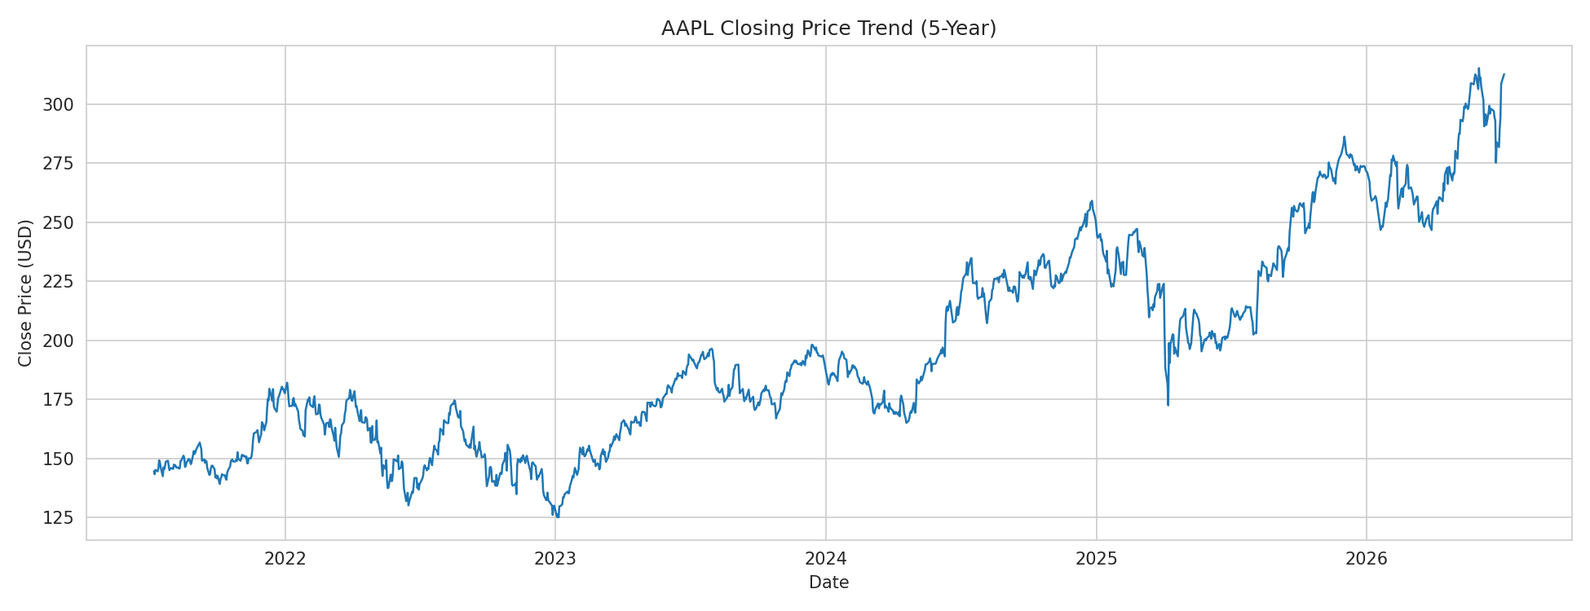
Figure 1: AAPL Closing Price Trend (5-Year)
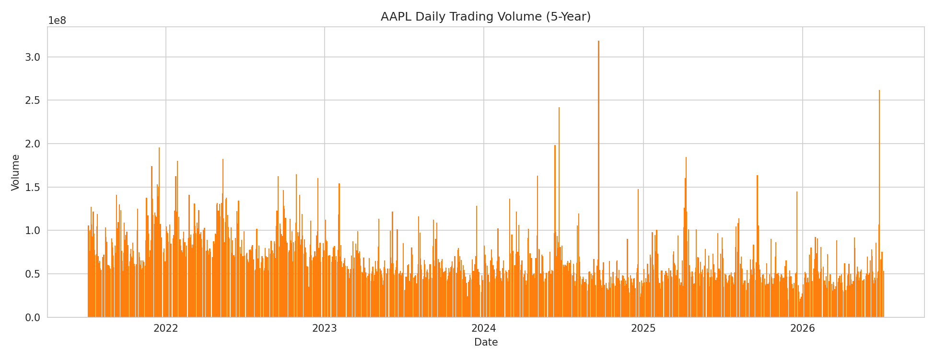
Figure 2: AAPL Daily Trading Volume (5-Year)
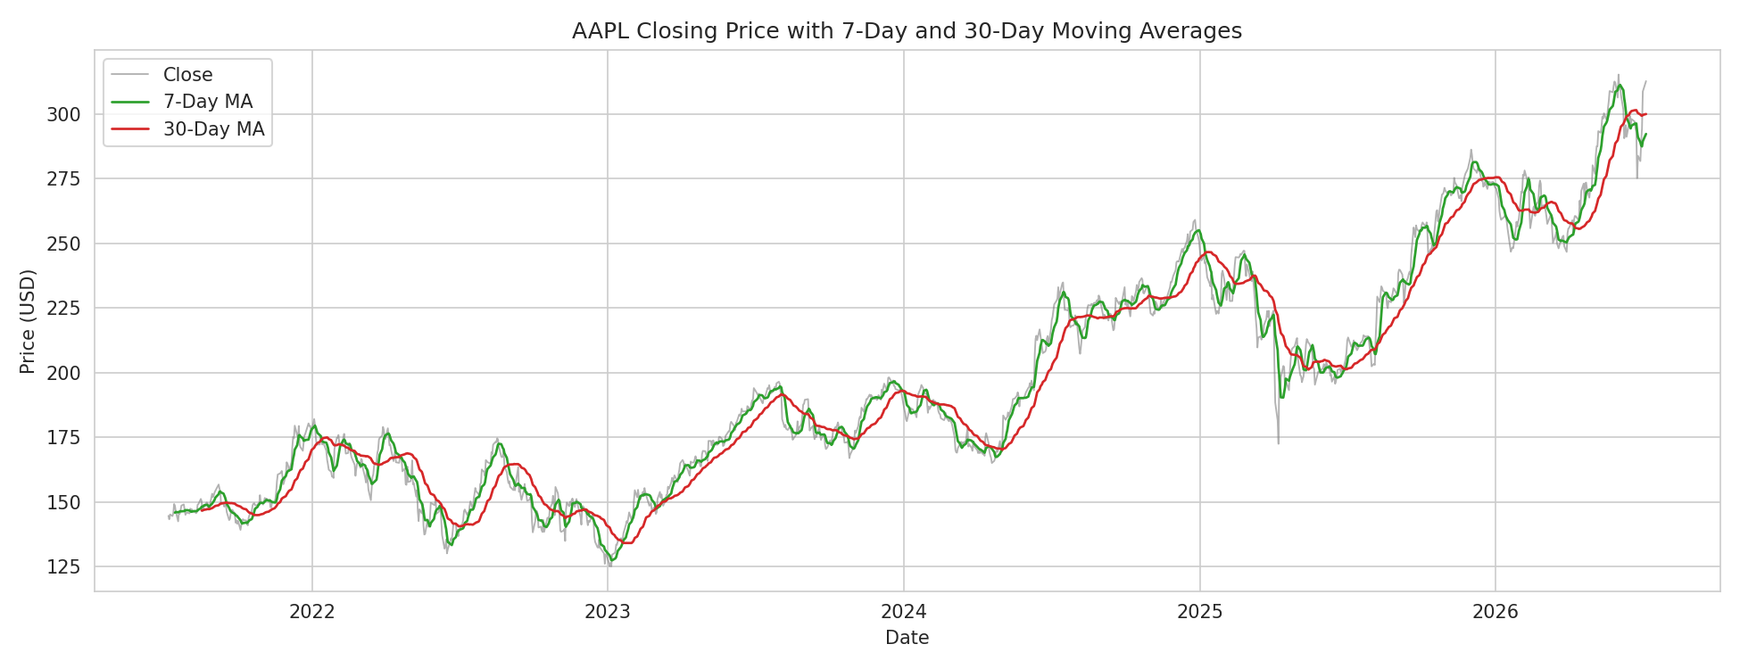
Figure 3: Closing Price with 7-Day and 30-Day Moving Averages
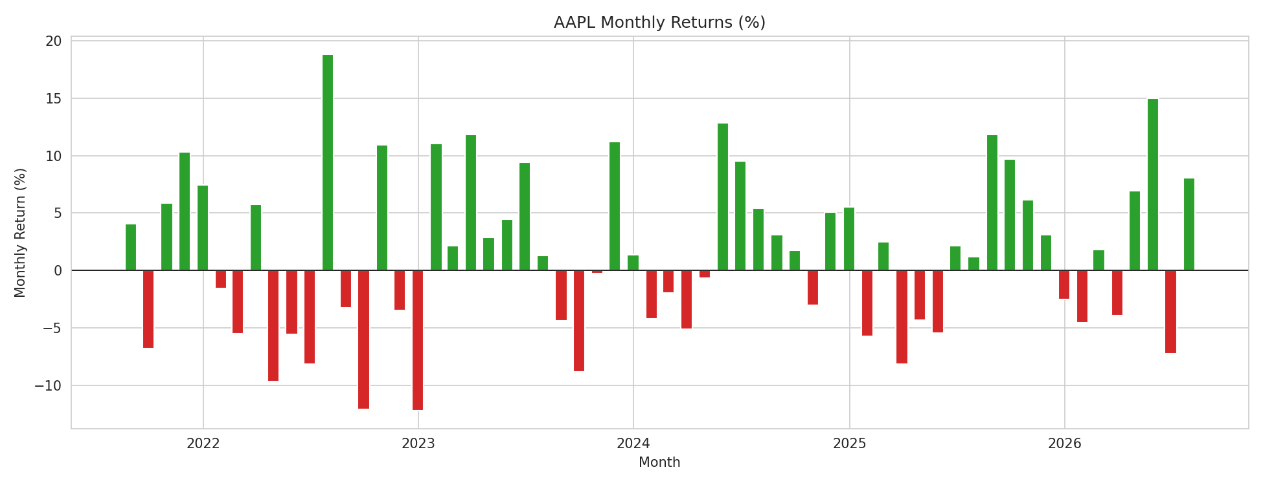
Figure 4: AAPL Monthly Returns (%)
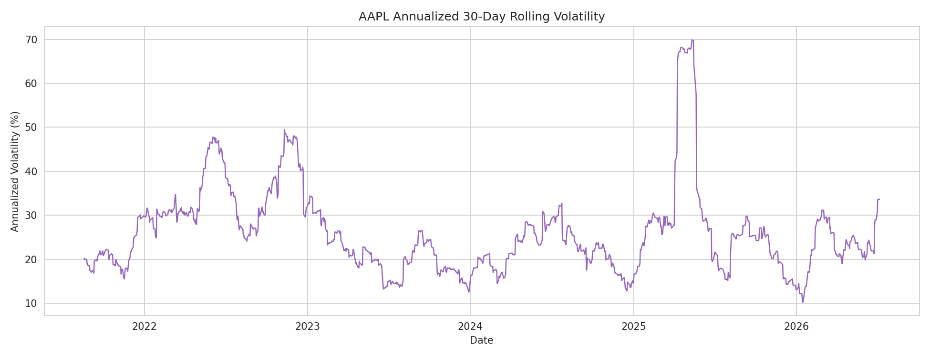
Figure 5: Annualized 30-Day Rolling Volatility

